Unit 3: Topic Test -Introduction to fuels Name:____________________

Mark out of 50: ____________

SECTION A – Multiple-choice questions

Instructions for Section A
Answer all questions.
Choose the response that is correct for the question.
A correct answer scores 1, an incorrect answer scores 0.
Marks are not deducted for incorrect answers.
If more than one answer is completed for any question, no mark will be given.

Question 1
Which of the following is the least renewable source of fuel for generating useful energy?

A. combustion of gas produced from waste
B. combustion of ethanol produced from potato peel
C. combustion of waste plastic
D. combustion of biodiesel produced from fish and chip shop oil

Question 2
Which of the following is the same for photosynthesis as for respiration?

A. the sign of ΔH in the reaction
B. the amount of energy when 1 mole of glucose is involved
C. the number of mole of products formed
D. the location of the reaction

Question 3
A balanced equation representing the formation of biodiesel from plant oil is

A. oil + 3methanol 3biodiesel + glycerol
B. oil + 3methanol 3biodiesel + 3CO₂
C. oil + methanol biodiesel + 3glycerol
D. 3oil + methanol 3biodiesel + glycerol

Question 4
Which one molecule of methane undergoes complete combustion

A. 2 bonds are broken and 2 bonds formed
B. 5 bonds are broken and 4 bonds formed
C. 6 bonds are broken and 4 bonds formed
D. 6 bonds are broken and 6 bonds formed
Use the following information to answer Questions 5 and 6
The equation for the complete combustion of ethane is

2C₂H₆(g) + 7O₂(g) 4CO₂(g) + 6H₂O(l)

A 90 g sample of ethane undergoes complete combustion and the gas produced is stored at SLC.

Question 5
The mass of CO₂ formed in the reaction is, in g,

A. 44
B. 88
C. 264
D. 528

Question 6
The volume of the product gases formed will be, in L,

A. 99
B. 149
C. 298
D. 372

Use the following information to answer Questions 7 and 8
The thermochemical equation for the reaction between aluminium and hydrochloric acid is

2Al(s) + 6HCl(aq) 2AlCl₃(aq) + 3H₂(g) ΔH = -88 kJ

Question 7
AlCl₃(aq) + $\frac{3}{2 }HCl$(aq) Al(s) + 3HCl(aq)

ΔH for the above reaction will be

A. 44 kJ
B. -44 kJ
C. 88 kJ
D. 176 kJ

Question 8
When 5.0 mol of aluminium reacts with 12.0 mol of HCl, the amount of energy released is

A. 88 kJ
B. 176 kJ
C. 220 kJ
D. 440 kJ

Question 9
A 50 g experimental food bar is made from protein and oil only. The energy available to the body from the protein in the bar is 255 kJ. The mass of oil in the food bar is

A. 25 g
B. 30 g
C. 35 g
D. 50 g

Question 10
Which of the following fuels can release the greatest amount of energy?

A. 6.02 x 10²³ molecules of hydrogen gas
B. 3.0 g of ethane
C. 0.10 mole of glucose
D. 12.4 L of methane at SLC

End of Section A

SECTION B- Short-answer questions

Instructions for Section B
Questions must be answered in the spaces provided in this book.
To obtain full marks for your responses you should
- Give simplified answers with an appropriate number of significant figures to all numerical questions; unsimplified answers will not be given full marks.
- Show all workings in your answers to numerical questions. No credit will be given for an incorrect answer unless it is accompanied by details of the working.
Make sure chemical equations are balanced and that the formulas for individual substances include an indication of state; for example, H₂(g); NaCl(s)

Question 1 (9 marks)
The energy profile diagram below is for the reaction between carbon monoxide and hydrogen gases to form liquid methanol. The magnitude of the activation energy for this reaction is 180 kJ and the value of ΔH is -320 kJ.
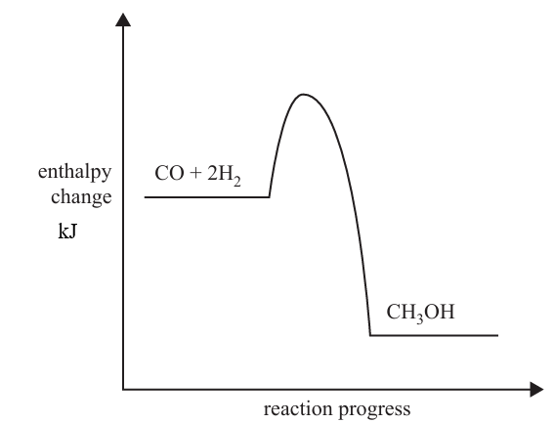
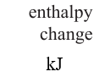
A

0
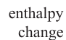

B

a. i. Write a thermochemical equation for this reaction. 1 mark

__________________________________________________________________________

ii. Indicate on the vertical axis, the energy levels at points A and B. 2 marks

iii. Determine the magnitude of the activation energy of the reverse reaction. 1 mark

__________________________________________________________________________

b. i. List the bond types that need to be broken when this reaction occurs. 1 mark

______________________________________________________________________________
ii. List the bond types that form when this reaction occurs. 1 mark

__________________________________________________________________________

iii. Which is greater – the magnitude of the energy required to break the bonds or the energy produced when
the bonds form? 1 mark

_________________________________________________________________________________

c. Determine the amount of energy released when 50.0 g of carbon monoxide reacts. 2 marks

_________________________________________________________________________________

_________________________________________________________________________________

Question 2 (16 marks)
Queensland has a bioethanol facility that uses the crop sorghum as its raw material. Sorghum is used as it has a higher cellulose content than most crops. Cellulose is a polymer of glucose.

Relevant data: Boiling point of ethanol 78⁰C
Density ethanol 79 g mL⁻¹
Bioethanol yield: 90000 L per hectare (hectare is a unit of area , referring to farm size)

The flowchart for the company’s process is drawn below.
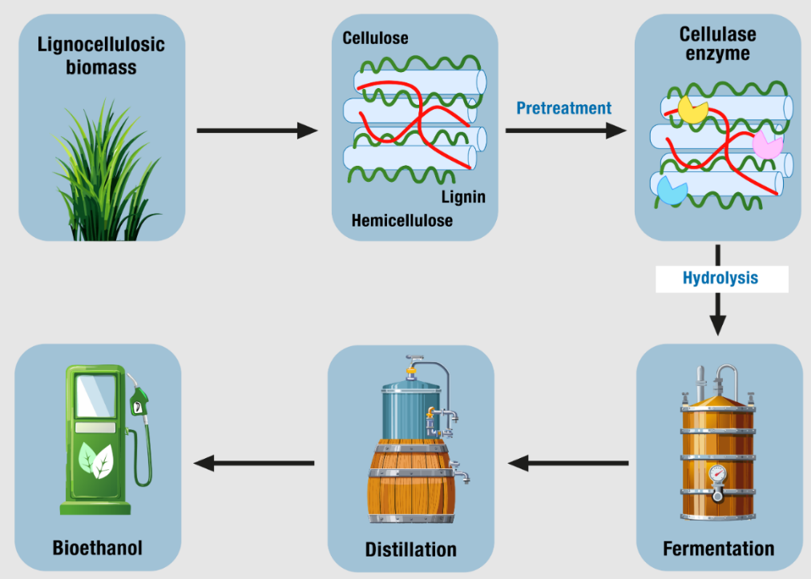

C
B
A

F
E
D

a. Write balanced equations for

i. the formation of a simple carbohydrate in the sorghum plant as it grows. 1 mark

__________________________________________________________________________________

ii. the fermentation reaction shown in the diagram. 1 mark

__________________________________________________________________________________

iii. the incomplete combustion of bioethanol to form carbon dioxide and water. 1 mark

________________________________________________________________________________

b. Explain the purpose of steps B and C in this process. 2 marks

__________________________________________________________________________________

__________________________________________________________________________________

__________________________________________________________________________________

c. Suggest a suitable temperature to use in step E. Justify your answer. 2 marks

__________________________________________________________________________________

__________________________________________________________________________________

__________________________________________________________________________________

d. The Queensland facility has a crop area of 1200 hectares.

i. Determine the volume of ethanol that is expected from this area. 1 mark

__________________________________________________________________________________

ii. Determine the mass of this ethanol. 1 mark

__________________________________________________________________________________

iii. Calculate the energy that can be obtained from the combustion of this ethanol. 2 marks

__________________________________________________________________________________

__________________________________________________________________________________

__________________________________________________________________________________

e. State one common use for the ethanol produced. 1 mark

__________________________________________________________________________________

f. The data book provides two different figures for the energy density of ethanol:

Item 12: ethanol(l) 1367 kJ mol⁻¹ and Item 14: bioethanol 29.7 kJ g⁻¹.
Are these figures a contradiction? (Include a calculation in your response) 2 marks

__________________________________________________________________________________

__________________________________________________________________________________

__________________________________________________________________________________

g. State a green chemistry principle that is relevant to the production of bioethanol and explain what the
connection is. 2 marks

__________________________________________________________________________________

__________________________________________________________________________________

__________________________________________________________________________________

Question 3 (11 marks)
The structures of a triglyceride and glucose are drawn below:

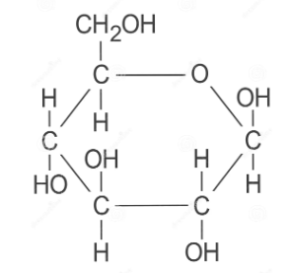
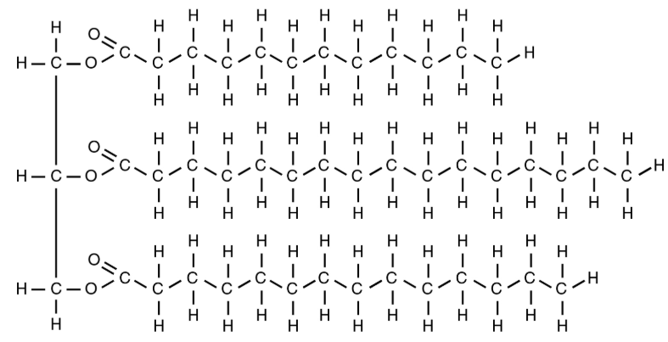
triglyceride glucose

a. i. Describe the changes that occur to the triglyceride molecule when it is converted to biodiesel. 3 marks

___________________________________________________________________________________

___________________________________________________________________________________

___________________________________________________________________________________

___________________________________________________________________________________

ii. Will the biodiesel formed from this molecule be a pure compound? Justify your answer. 2 marks

___________________________________________________________________________________

___________________________________________________________________________________

___________________________________________________________________________________

iii. State a viable source of triglycerides in Australia. 1 mark

____________________________________________________________________________________

b. i. Which of the above compounds will produce the most energy per gram when consumed? 1 mark

ii. Explain your choice in part i. by referring to the structures shown. 2 marks

___________________________________________________________________________________

___________________________________________________________________________________

___________________________________________________________________________________

c. Write an equation for the complete combustion of glucose. 1 mark

____________________________________________________________________________________

d. Determine the energy available to a human from the consumption of a food item containing 10 g of the
triglyceride above and 10 g of glucose. 1 mark

___________________________________________________________________________________

___________________________________________________________________________________

Question 4 (4 marks)

a. Write a thermochemical equation for the complete combustion of ethane. 1 mark

___________________________________________________________________________________

b. i. State the molar heat of combustion of ethane. ___________________ 1 mark

ii. State the molar enthalpy of combustion of ethane. _______________ 1 mark

c. If the water produced during combustion remains as a gas, how, if at all is the value of ΔH in the data book
impacted?

__________________________________________________________________________

__________________________________________________________________________

END OF KEY TOPIC TEST

